Unravelling The Complex Process-Structure-Property Relationships In Polymers Using Artificial Intelligence

Polymer crystallization is a complex, stochastic, and kinetics-governed process, making it challenging to uncover the relationships between thermal processing conditions, the resulting microstructural states of semi-crystalline polymers, and their corresponding material properties. To better understand polymer crystallization mechanisms, existing approaches have included: (1) traditional thermodynamics-based models, such as the Avrami equation and Nakamura model, which parameterize nucleation and growth kinetics; and (2) data-driven approaches that predict quantitative characteristics of processed polymers, such as crystallinity and enthalpy.
However, both approaches are limited in their ability to fully capture the complex process–structure–property relationships in polymers. Traditional thermodynamic models rely on idealized assumptions regarding crystallization mechanisms, making them insufficient for describing complex, multi-stage crystallization behavior under realistic thermal processing conditions. Existing machine learning methods, while capable of predicting scalar thermal and structural characteristics, do not fully represent the underlying microstructure of the material, which contains comprehensive information related to its actual properties. Therefore, it is essential to accurately map processing conditions to microstructural states, and subsequently to material properties.
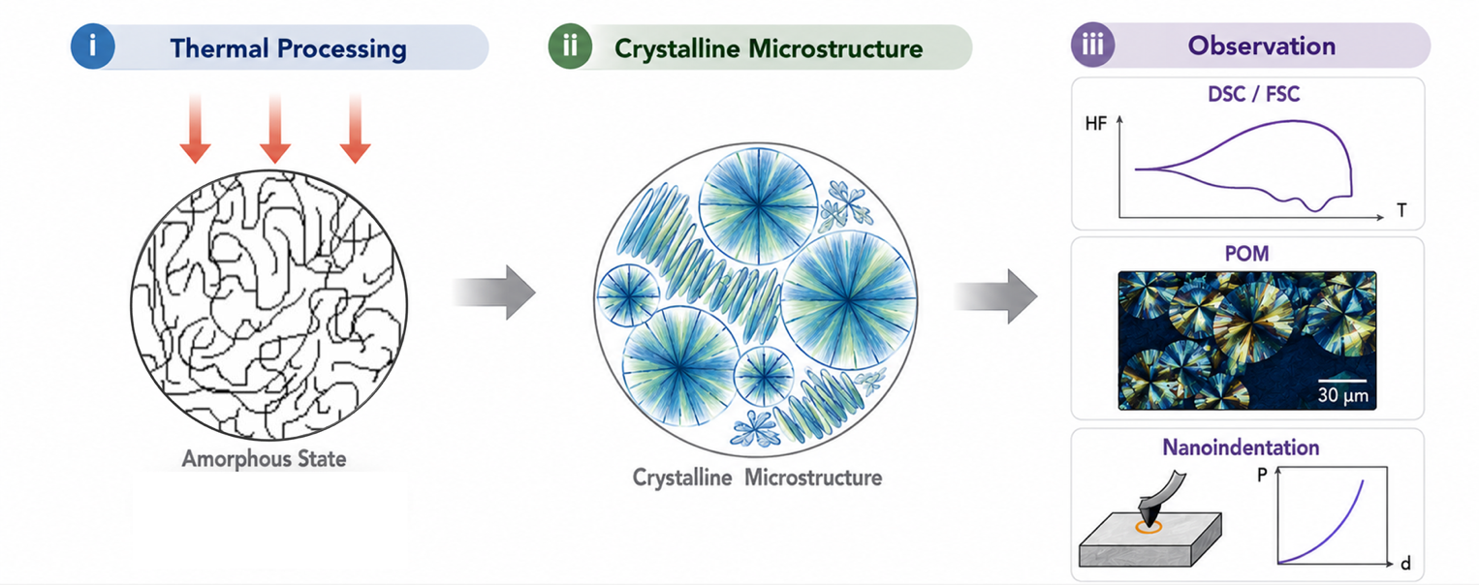
In this work, we explore artificial neural network (ANN) approaches to unravel the complex relationships among thermal processing, microstructural evolution, and the resulting properties of semi-crystalline polymers. ANNs are well suited for modeling complex and nonlinear relationships due to their ability to learn meaningful data representations from experimental datasets. While thermal processing can be implemented through a variety of processing routes, the resulting microstructural states and material properties can be characterized using techniques such as Differential Scanning Calorimetry (DSC), Flash Differential Scanning Calorimetry (FSC), Polarized Optical Microscopy (POM), nanoindentation, and related methods. By training ANN models on experimental datasets, we aim to establish a framework for understanding the crystallization mechanisms governed by thermal processing, which ultimately determine the final microstructure, material properties, and mechanical performance of semi-crystalline polymers (see Figure 1).

Figure 1: Schematic overview illustrating the workflow used in AI data processing that uncovers process-structure-property relationships relevant to polymer crystallization.

