Microstructure Modification, Mechanisms, And Future Outlook In Polymer Foaming

Considering growing sustainability concerns, materials scientists and engineers have increasingly explored polymer foaming as a promising approach for reducing material consumption while producing lightweight structures. Within this field, flexible foams with compressive resistance, high energy restitution, and excellent recovery are of particular interest for high-performance applications beyond conventional lightweighting. Unfortunately, these foams are typically derived from vulcanized rubbers or chemically crosslinked elastomers, whose covalent networks inhibit conventional recycling and reprocessing methods. This has driven interest in polyolefins such as polypropylene (PP), and their elastomers, such as ethylene-propylene (EP) copolymers, which are both cost-effective and highly recyclable. However, PP and EP copolymers exhibit poor foaming ability due to their inherently low melt strength, stemming from their linear chain architecture. In the melt state, these resins are unable to withstand the extensional stresses encountered during foaming, leading to foams with poor morphology, characterized by large cell sizes and low cell densities, which ultimately hinder mechanical performance. Traditional means to overcome this include chemical crosslinking, blending with high-melt-strength polymers, or introducing long-chain branching into the architecture of the polymer microstructure. Unfortunately, these solutions present distinct drawbacks, in which chemical crosslinking creates permanent networks eradicating recyclability, blending causes miscibility issues, and long-chain branching synthesis is extremely costly. Therefore, foaming these resins requires a low-cost strategy that enhances melt strength and, in turn, foaming ability, while retaining its recyclable nature.
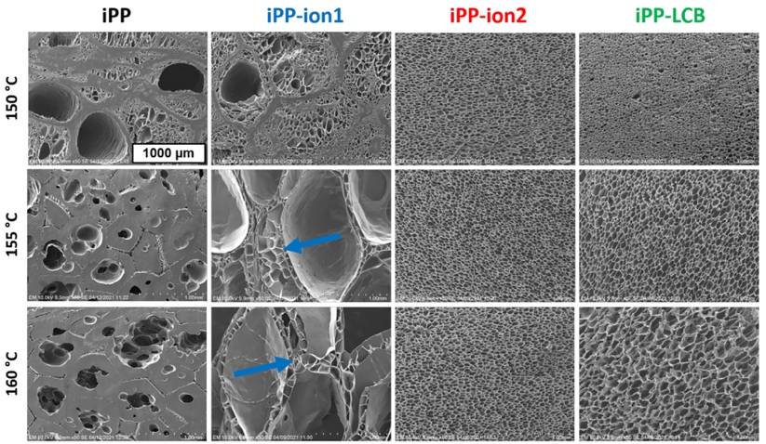
This work investigates how ionic and vitrimer modification influence the rheological, crystallization, and foaming behaviour of PP and EP copolymers (see Figure 1), with both approaches imparting strain hardening and accelerating crystallization, demonstrating strong potential for foaming applications. Beyond conventional characterization through expansion ratio and cell morphology screening, in-situ visualization serves as a powerful tool for examining cell nucleation and coalescence behaviour; if required, this visualization tool also has the capability to capture the crystallization of these resins under foaming conditions, further elucidating the underlying mechanisms of these resins. With the large volume of experimental data that has been collected this research group also has interest in developing predictive models to reduce the time and material costs associated with resin screening. In collaboration with the Korea Advanced Institute of Science & Technology (KAIST), Daejeon, a machine learning model was developed that accurately predicts foaming behavior based on key molecular parameters. Ultimately, the implications of this work extend to industrial foaming practices, including processes like tandem extrusion.

Figure 1: Foam morphologies obtained from SEM using ×50 magnification for resins treated at different foaming temperatures. Blue arrows refer to the high cell density regions.

