Graph Neural Network-based Grasp/Support Layout Planning under External Dynamic Loading
Existing studies on object grasping have primarily focused on contact-induced deformation and displacement resulting from interaction with robotic grippers. More recent approaches based on graph neural networks (GNNs) have demonstrated strong performance in predicting deformation and stress fields, as well as evaluating grasp quality for compliant objects. However, these methods are typically limited to quasi-static contact assumptions and do not explicitly account for external dynamic loading conditions acting on the object.
To address these limitations, we explore a new framework that integrates: (i) understanding of object geometry and stiffness, (ii) prediction of deformation under external dynamic loading, and (iii) optimization of grasp or support layouts that minimize structural deformation under such conditions. While the ultimate application space lies in robotics—particularly motion planning and grasp force control for robotic manipulators—the present work focuses specifically on the optimization of support layouts as the core problem.
For this project, there are two requirements:
- FEM-based Data Generation: Training data will be generated using high-fidelity finite element simulations. Simulation Tools can be ANSYS and LS-DYNA. The required output information includes displacement field, stress/strain distribution, maximum deformation metrics from diverse geometries and properties of materials (see Figure 1).
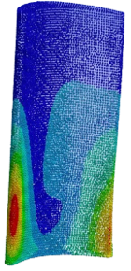
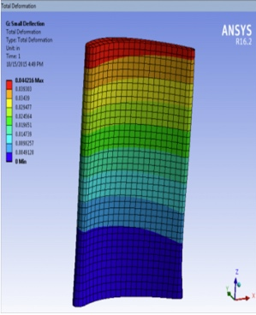

Figure 1: Examples of FEM-based dataset and point cloud of the object with predicted stress distribution

- Computer Vision: The roles of computer vision components include converting observed object geometry into graphical representation and providing geometry-aware inputs to the GNN-based AI model. This involves point cloud processing, mesh reconstruction and pose estimation.
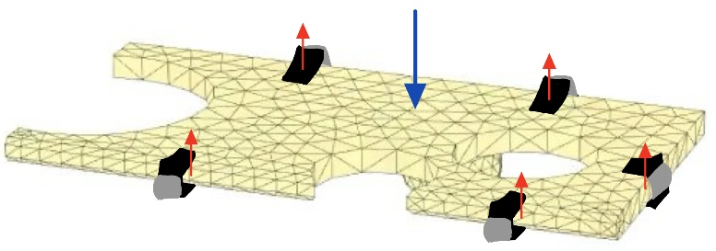

Figure 2: Optimized grasp/support layouts for diverse geometries, properties and external forces to minimize the deformation and displacement of workpieces.

