Bio-Inspired Nacre Structure Using Brick-And-Mortar Architecture For Multi-Layered Polymer Composites

Natural nacre (mother-of-pearl) exhibits exceptional mechanical properties through its hierarchical brick-and-mortar architecture, combining organic and inorganic elements in a highly regular arrangement. This bio-inspired structure provides an excellent balance between strength and toughness while effectively dissipating stress, resisting fracture propagation, and exhibiting superior energy absorption. Inspired by these properties, researchers have developed polyurethane using laser-induced graphene (LIG) as the hard phase and polyurethane (PU) as the soft phase. This research has significant potential for applications in flexible electronics, wearable devices, and structural materials requiring both strength and resilience. Conventional single-layer polymer materials, however, suffer from several critical limitations, including poor mechanical performance, low fracture resistance, limited energy absorption, and inflexibility. These materials often fail to effectively dissipate stress or stop crack propagation, resulting in brittleness and structural failure.
To address these limitations, the work uses a nacre-inspired multilayer polymer structure containing LIG and PU. In this design, LIG serves as the organized hard phase, consisting of hard plates approximately 200–900 nm thick, while PU acts as the alternating soft layer with thicknesses ranging from 10–50 μm. The controlled volume ratio of approximately 80:20 to 95:5 hard-to-soft phase ratio mimics natural nacre, and the structure is arranged hierarchically across nano- to macro-level scales. Experimental comparisons between single-layered LIG/PU composites and the multilayer nacre-inspired LIG/PU composites showed substantial improvements in tensile modulus and maintained ductility. These multilayer structures demonstrated enhanced flexibility while preserving high mechanical performance.
The superior performance of the multilayer architecture is attributed to its improved stress distribution and fracture resistance. Crack deflection mechanisms help dissipate energy and prevent catastrophic failure, while the multiple interfaces within the structure enhance energy absorption through interfacial sliding and pathway tortuosity. Overall, the nacre-inspired multilayer design achieves an optimized balance between flexibility and rigidity, making it highly promising for advanced engineering applications. Future research directions involve tailoring structural characteristics, establishing deeper structure–property relationships, and functional property assessments/optimization for flexible electronic applications.
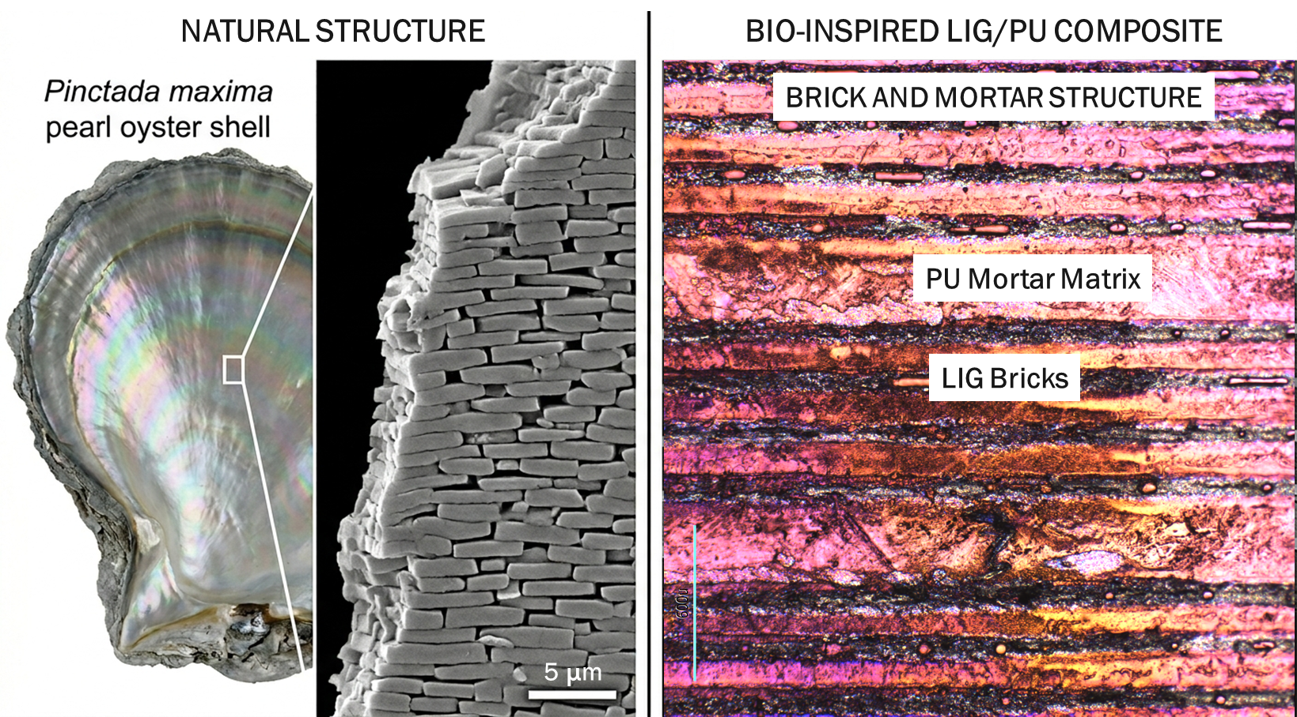
Figure 1: Naturally occurring brick-and-mortar structure present in nacre, and synthetic analogue prepared by laser processing.

